**Week-2**

In this Week, they provide instruction to setup Eclipse and JAVA JDK on our system.

Go through this link to know more about unfolding map:

[http://unfoldingmaps.org/tutorials/mapprovider-and-tiles.html#](http://unfoldingmaps.org/tutorials/mapprovider-and-tiles.html)

**Note: downgrade the JRE file to 1.8 or 1.7 and JDK compiler compliance level to 1.8**

**Downloading and Setting Up the Starter Code for project:**

1. Download the starter code zip file from this folder
2. Extract the zip file somewhere outside of your Eclipse workspace folder.
3. Open Eclipse if it is not already open.
4. From the File menu in Eclipse select “Import…”
5. In the Import window, expand General and select “Existing Projects into Workspace”. Then click “Next >”
6. In the window that appears, click “Browse” next to "Select root directory” (keep this option selected).
7. In the File Chooser, browse to where you uncompressed the starter code. It should be in a folder named “UCSDUnfoldingMaps”. Select this folder (NOT one of the subfolders or higher level folders) and click “OK”.
8. You should see the UCSDUnfoldingMaps project selected under Projects. Make sure the option to "Copy projects into workspace" is checked, then click “Finish”.
9. Now, you should see the project in your Eclipse workspace. In the Package Explorer you will see the UCSDUnfoldingMaps project. If you expand this project you will see several folders including src, data and some library folders. src is where all of your source (Java) code that we provide is located. This is also where all the code you will write will be placed.
10. Finally, notice that when you imported this project into Eclipse you got a COPY of all of the starter code files you downloaded into your workspace

That’s it! You’re all set up and ready to go.

For assignment of week 2 as project in the above ZIP file

in module 1 of UCSDUnfoldingMaps we have to create a second half of map just like first one

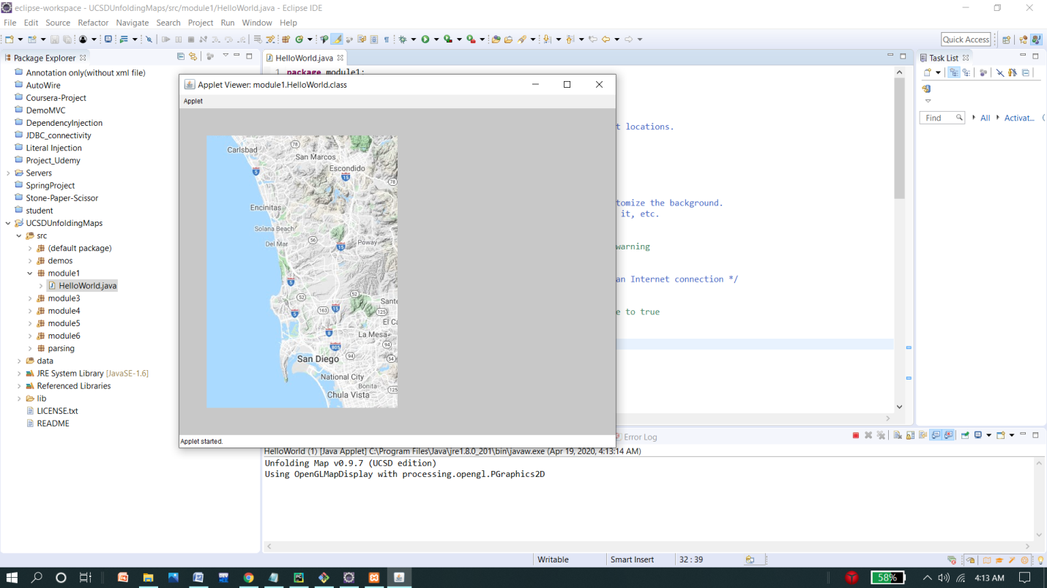

In this 2nd portion we have to draw some map as assignment for this week

Hint: We just have to do some minor changes in setup() function and draw() function